**Sourcecode:**

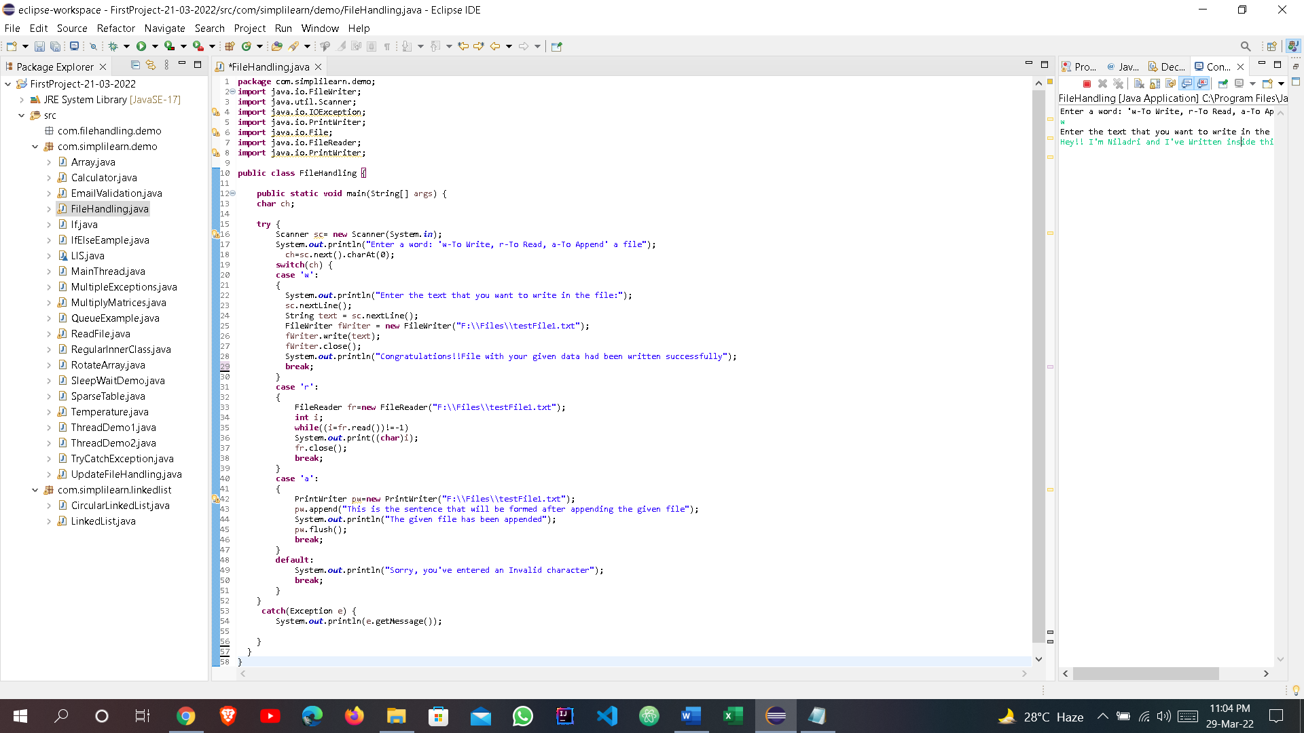

**Output:**

**1.Writing inside a file:**

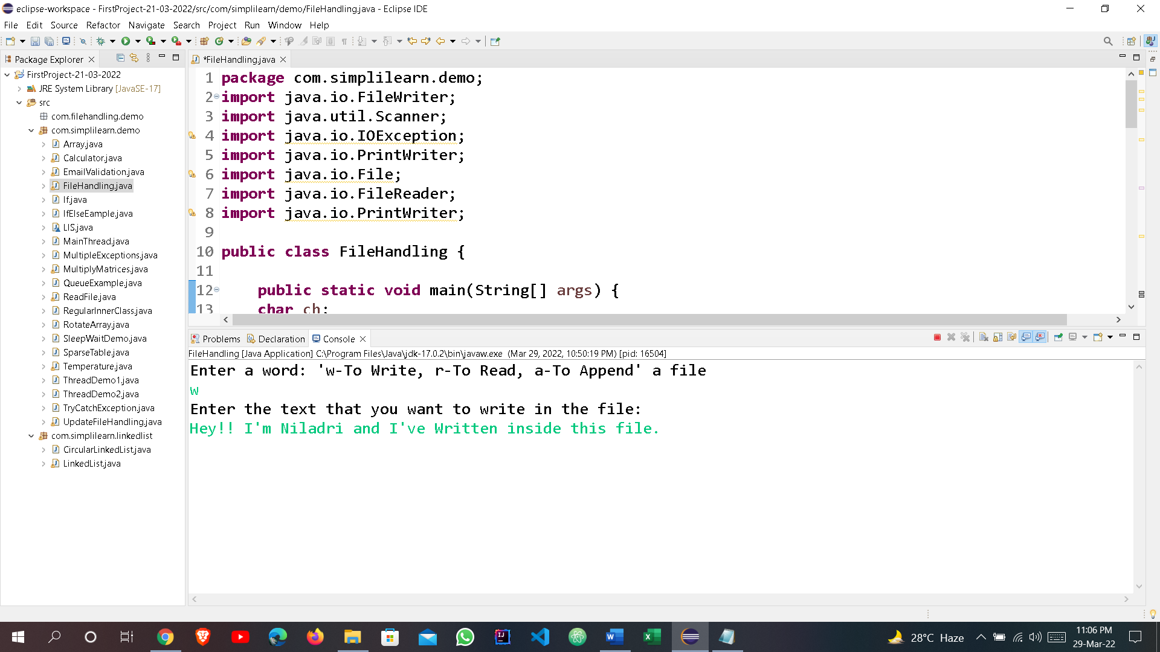

**2.Reading what’s there inside a file:**

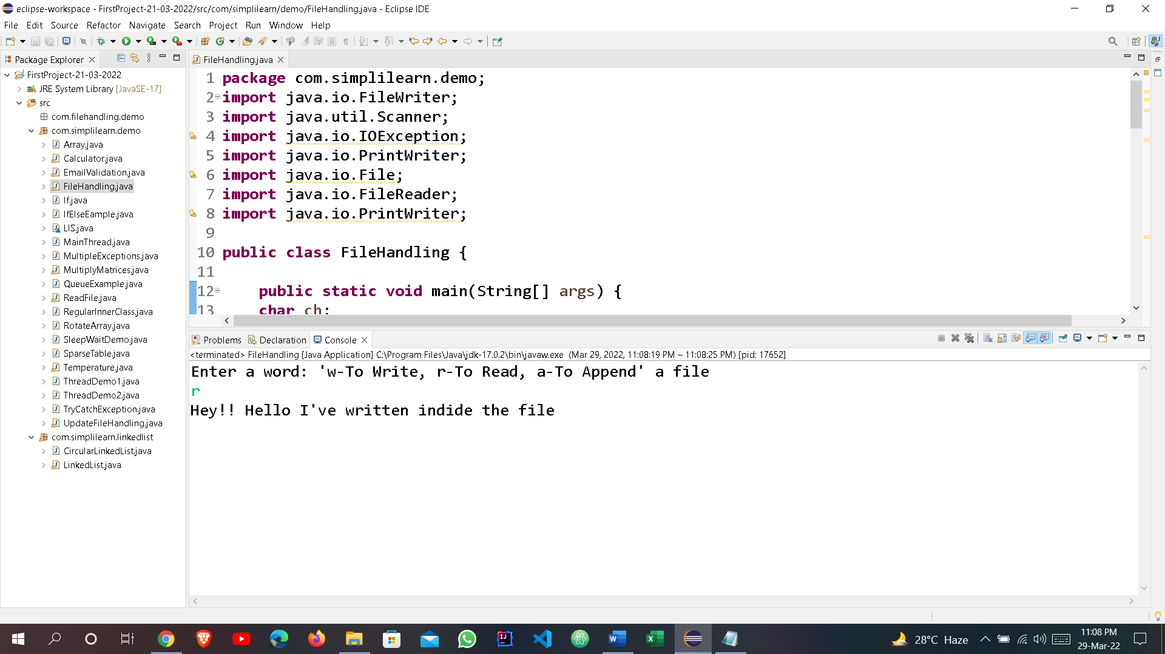

**3.Appending the file:**

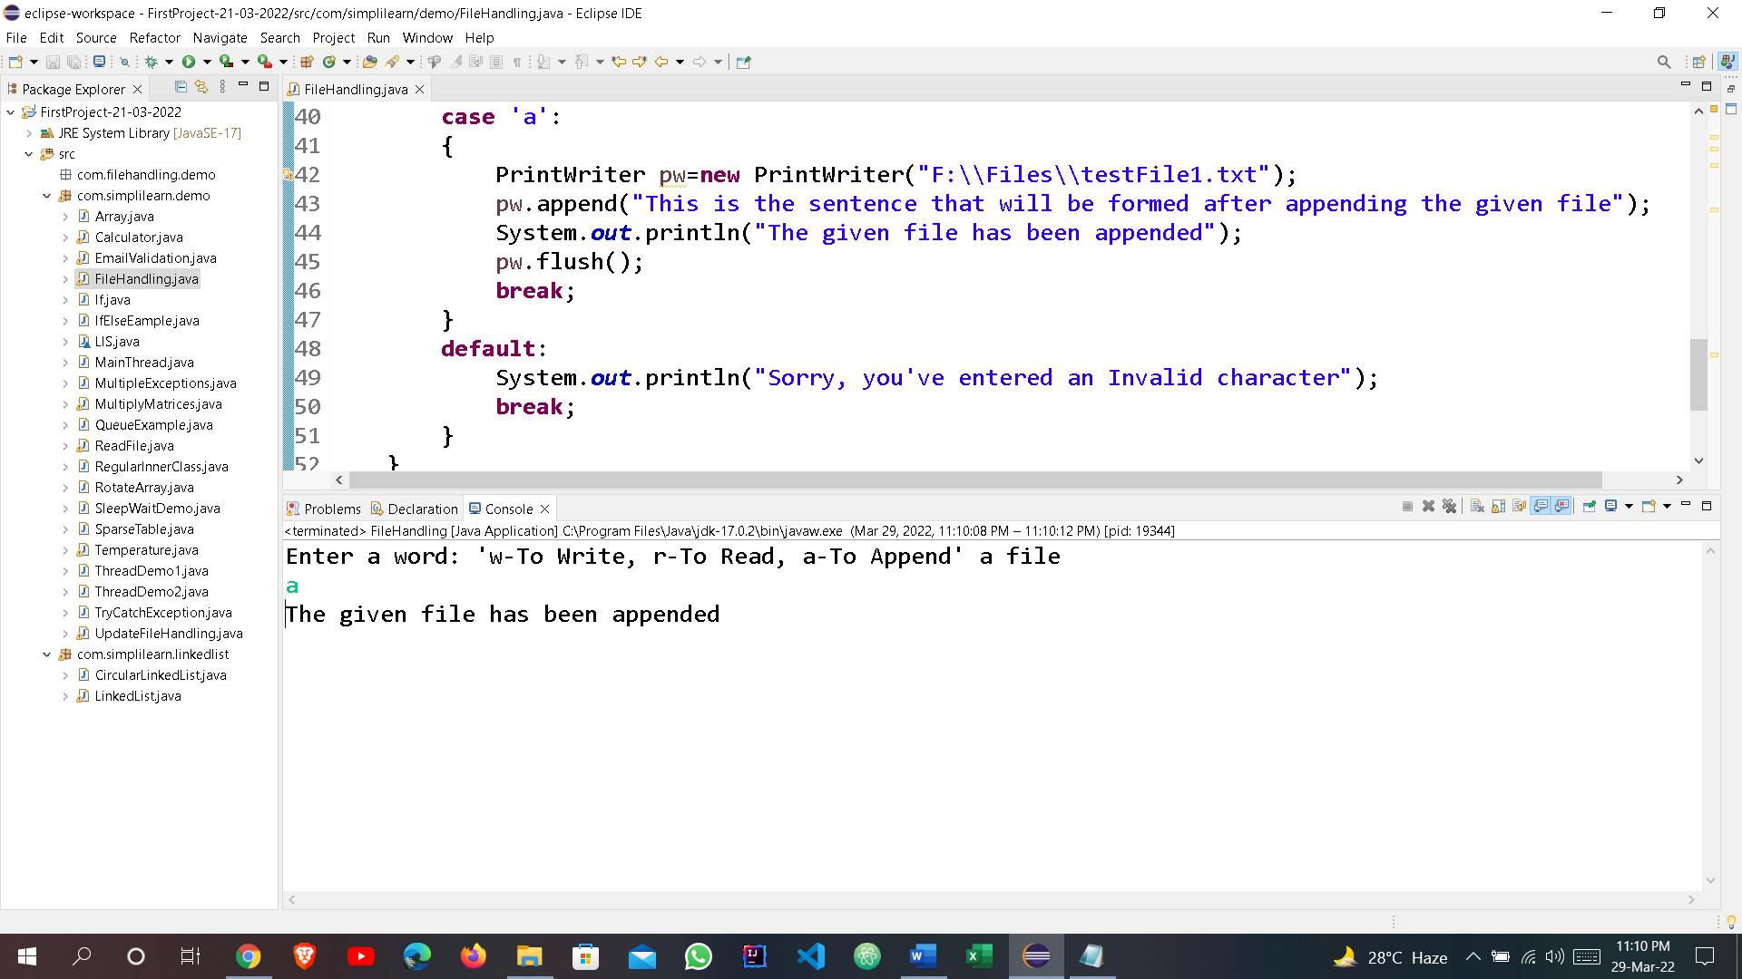

**4.If the user puts any other character than what was given in the program:**

